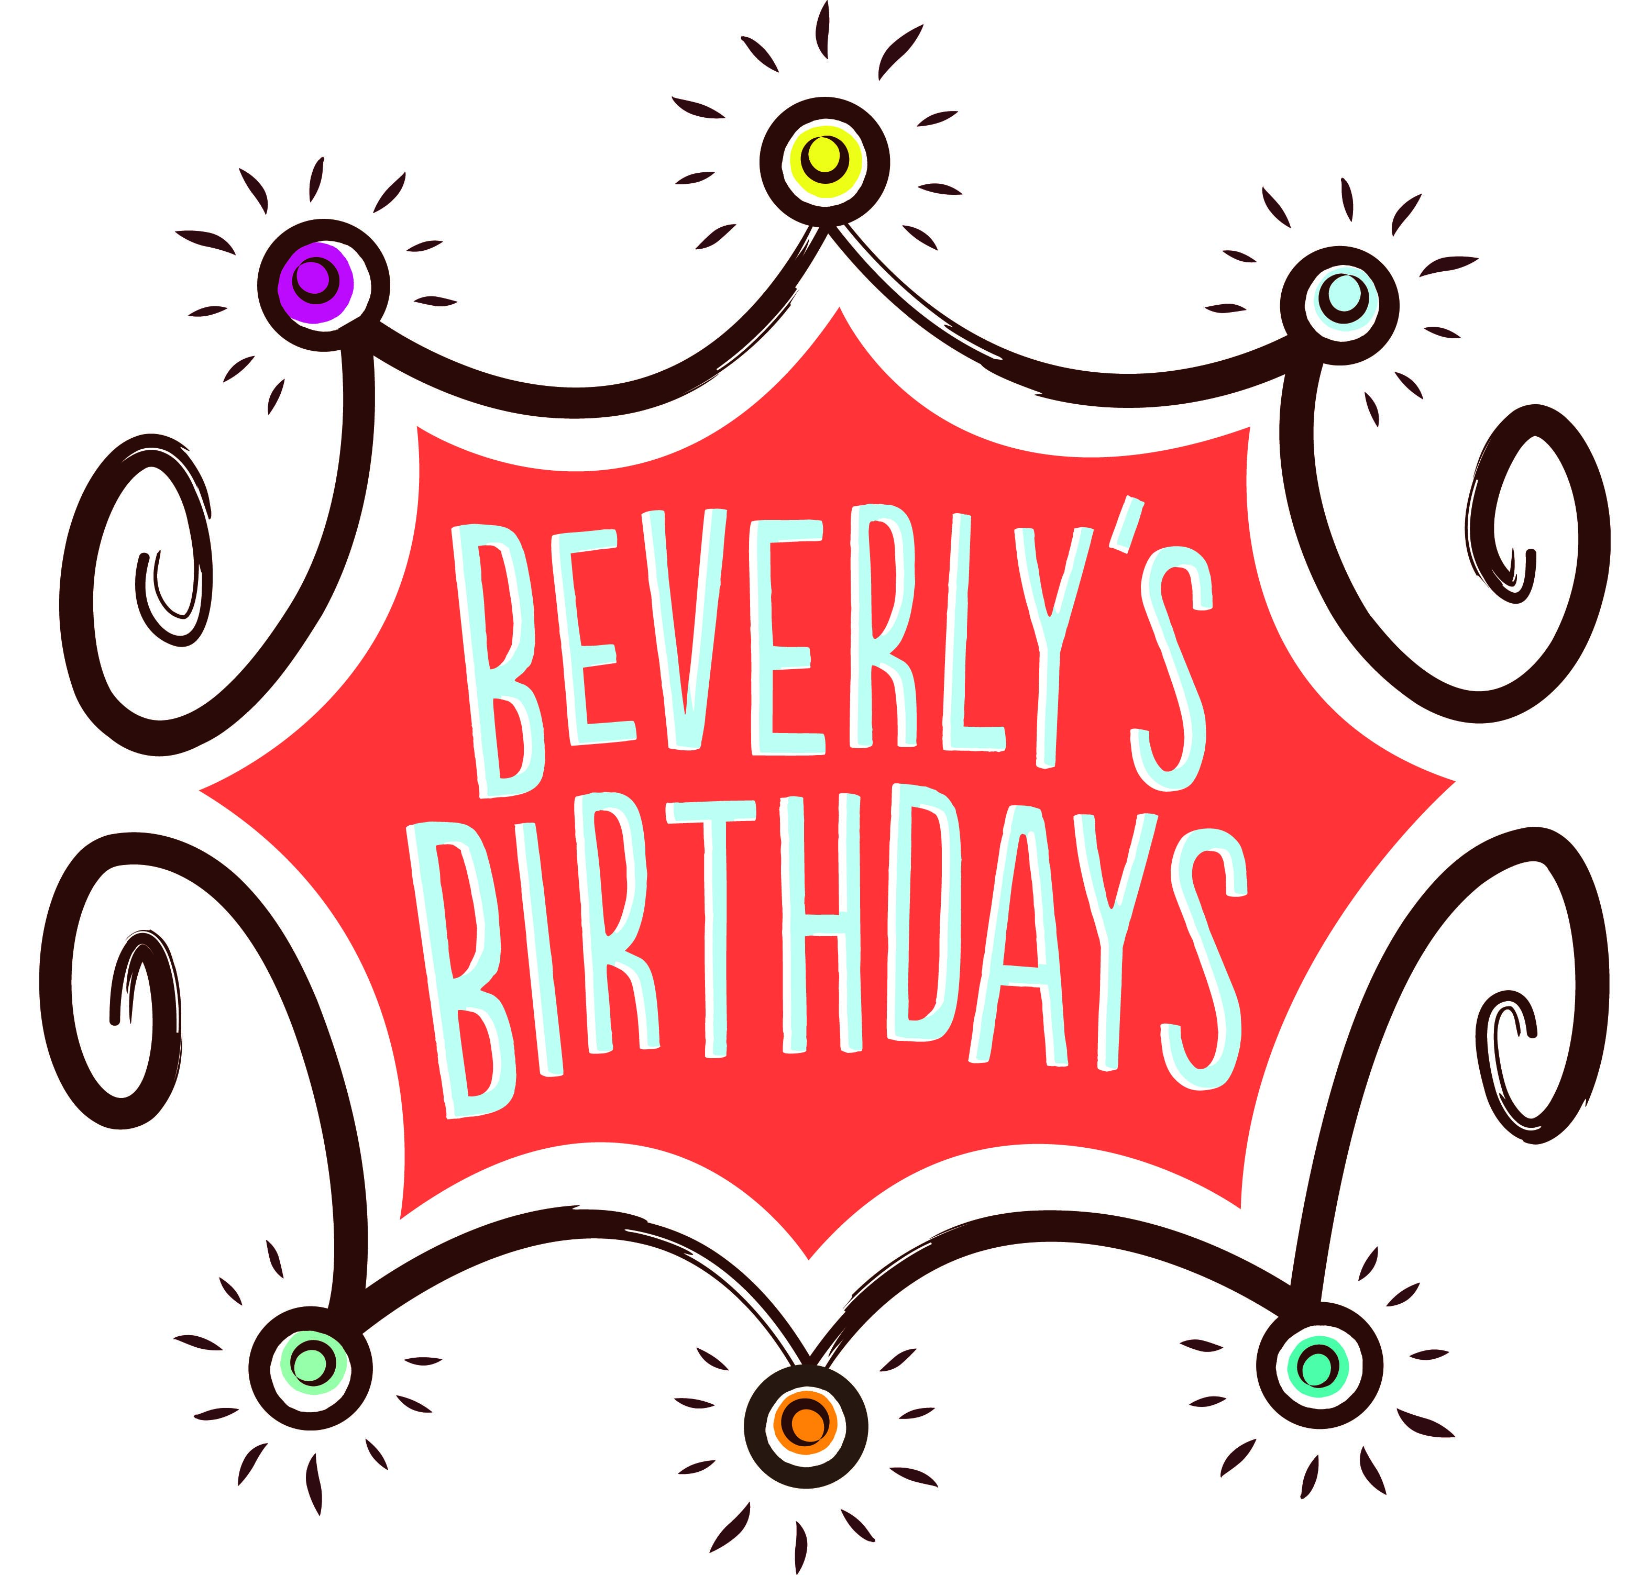
In-Kind Donation Wish List
Birthday Cheer Bin Wish List

- Axe Body Spray Sets (teen boys)
- Makeup and Bath and Body Works Sets
- McDonalds, Subway, Dunkin Donuts gift cards
- Juice Boxes/Capri Suns
- Toddler and baby toys
- Diverse baby dolls
- Make believe playsets (kitchen toys, costumes, etc.)
- Toys appropriate for girls 4-9 (i.e.- Barbie, Dora, My Little Ponies, Hello Kitty, Lisa Frank, etc.)
- Toys appropriate for boys 4-9 (i.e. – Superheroes, Paw Patrol, Dinosaurs, Teenage Mutant Ninja Turtles)
- Duplo and Lego Sets
- Pittsburgh Sports Accessories (Hats, Posters, Bags, etc.)
- Toothbrushes/Toothpaste
- Books (all ages)
- Boardgames
- Tech toys for teenagers

Itty Bitty Birthday Cheer Bin Wish List

- Diapers (Size 1)
- Wipes
- Baby Board Books
- Pacifiers
- Bottles
- Sleepers (0-3 months)
- Baby Toys
The Birthday Boutique
- Underwear (toddler to teen)
- Socks (toddler to teen)
- Pajamas (toddler to teen)
- Hair Bows/Headbands
- Outfits (3 months to adult)

Birthday in a Bag Wish List

- Candles
- Cake Mix
- Icing
- A set of general birthday tableware (napkins, cups, tablecloth, plates, cutlery)

all items can be arranged to be dropped off at beverly’s birthdays headquarters.
please contact us at getinvolved@beverlysbirthdays.org if you would like to organize a collection drive.

