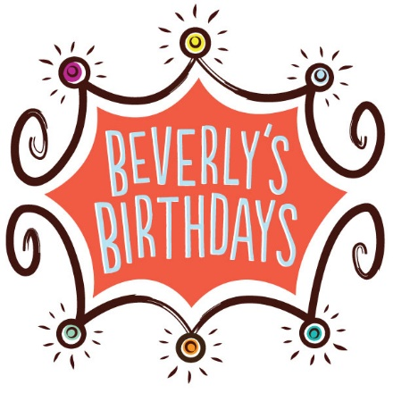

2019 CORPORATE SPONSORSHIP PLATFORM SUBMISSION FORM

After reviewing the 2019 Corporate Sponsorship Platform Packet, please complete this form and return it to
Megs Yunn at myunn@beverlysbirthdays.org or:
Attention: Beverly’s Birthdays
9799 Laurel Avenue
North Huntingdon, PA 15642

If you have any questions, please call Megs Yunn at 412-720-9737
Please select the sponsorship level for 2019:

□ $10,000 TITLE SPONSOR
□ $5,000 PLATINUM SPONSOR
□ $2,500 GOLD SPONSOR
□ $1,000 SILVER SPONSOR
□ $500 BRONZE SPONSOR
□ $250 PARTY SPONSOR (NOTE- RECOGNITION FOR EVENING OF BIRTHDAY CHEER EVENT ONLY)

COMPANY/DONOR (as it should appear on sponsorship): __________________________________________________
IF COMPANY, NAME OF CONTACT PERSON:__________________________________________________________

ADDRESS:________________________________________________CITY:_______________________STATE:______

ZIP:_________________PHONE:__________________________EMAIL:______________________________________

We will contact you shortly after receiving your completed form to confirm the details of your sponsorship. Thank you!

