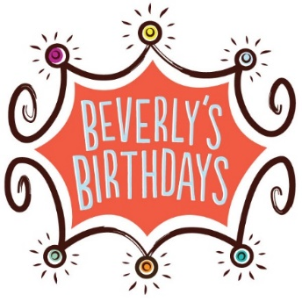

2020 CORPORATE SPONSORSHIP PLATFORM SUBMISSION FORM

After reviewing the 2019 Corporate Sponsorship Platform Packet, please complete this form and return it to
Ashley Bright at abright@beverlysbirthdays.org or:
Beverly’s Birthdays
Attention: Ashley Bright
9799 Laurel Avenue
North Huntingdon, PA 15642
If you have any questions, please call Ashley Bright at 814-386-0325
Please select the sponsorship level for 2020:

□ $25,000 Hope On A Hanger

□ $10,000 Champion of Cheer
□ $5,000 Celebrate & Spread Cheer
□ $2,500 Itty Bitty Birthday Magic
□ $1,000 Cupcakes & Candles
-(NOTE- THE BELOW LEVELS ARE RECOGNITION FOR EVENING OF BIRTHDAY CHEER EVENT ONLY)-
□$750 You Matter
□ $500 Birthday Wishes Come True
□ $250 Let’s Party

COMPANY/DONOR (as it should appear in print): ________________________________________________
IF COMPANY, NAME OF CONTACT PERSON:____________________________________________________

ADDRESS:_________________________________________CITY:_______________________STATE:______

ZIP:_________________PHONE:__________________________EMAIL:_______________________________

We will contact you shortly after receiving your completed form to confirm the details of your sponsorship. Thank you!

