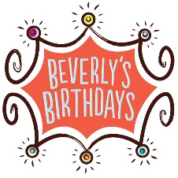

How to organize a Collection for a Cause
Thank you for your interest in wanting to organize a donation drive, in-kind or monetary, for Beverly’s Birthdays.
Here is how you can get started:
Step 1: Reach Out
Let us know you want to organize a Collection for a Cause. E-mail our Community Engagement Manager, Bonnie Rolison, and she can help walk you through the process.
Bonnie Rolison
brolison@beverlysbirthdays.org
724-590-5106
Step 2: Collection for a Cause Types
Determine what type of collection drive you want to organize, in-kind or monetary. Depending on the time of year, we have higher priority needs and so we always welcome the opportunity to coordinate with you before you start organizing.
- Birthday Cheer Bin Toy Drive
- Itty Bitty Birthday Cheer Baby Supply Drive
- Birthday in a Bag Supply Drive
- Happy Hygiene Kits Supply Drive
- Bev’s Basics Kits Supply Drive
- The Birthday Boutique Clothing Drive
- Gift-Card Collection Drive
- Snack Pack Collection Drive
(An item need list for each type of collection drive is provided at the end of this document)
Step 3: Ready to Spread Cheer
Once you have determined the type of collection drive you want to organize and have connected with our Community Engagement Manager to solidify the details, you are ready to get started.
Additionally, here are a few tips to remember when collecting:
- Keep your ask specific – the less choices people have, the better the collection drive
- Ask us for branding material, we are happy to provide you with materials
- If you create a flyer, we are happy to review it before you send it out
- Make your collection boxes look fun and eye catching – try wrapping boxes in birthday wrapping paper OR ask us for one of collection boxes (suitable for large group/company drives)
Step 4: Collection Completion
Once your collection is complete, reach back out to coordinate a time for you to drop off your items at our North Huntingdon, PA headquarters. Depending on the size of the collection drive, and with advance notice, we can coordinate picking up the items. This is determined on a project by project basis.

Collection for a Cause – Wish Lists
BIRTHDAY CHEER BIN TOY DRIVE
We distribute Birthday Cheer Bins (present packages) to over 4,500 children annually. Therefore, we are always in need of toys for all ages 0-21. In every bin, we always include a mixture of large gifts, small stocking stuffer size items, toothbrushes, toothpaste, a snack, and a new book:
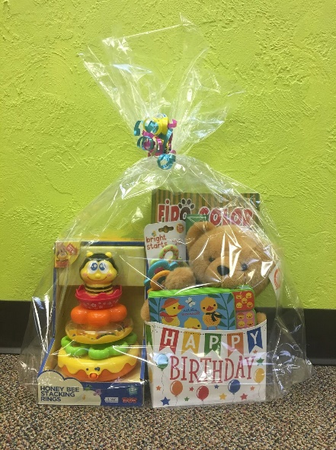
Here are a few of our favorite toy items:
- Crayons/Coloring Pencils
- Coloring Books (child and adult)
- Toddler Toys
- Books (Baby-Teens)
- Baby Dolls/Barbies (Diverse skin tones)
- Legos/Duplos
- Arts & Crafts Kits
- Dress-Up/Creative Play
- Action Figures/Super Heroes
- Makeup
- Popular Characters (LOL, Paw Patrol, Peppa Pig, Superheroes, Disney, Sesame Street, PJ Masks, Shimmer & Shine, Star Wars)
ITTY BITTY BIRTHDAY CHEER BABY SUPPLY DRIVE
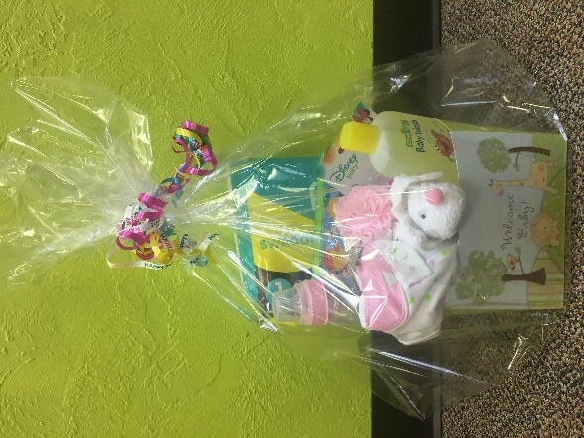
We distribute newborn care packages, Itty Bitty Birthday Cheer Bins, to over 1,000 expecting mothers in need annually. An Itty Birthday Cheer Bin always contains:
- 1 pack of size 1 diapers
- 1 pack of wipes
- 1 new book
- 1 pack of pacifiers
- 1 0-3 months sleeper
- 1 bottle
- 1 small baby toy or hygiene item
** Additional Opportunity – If your group would like us to come to your office/meeting/club/etc. we can bring the packing materials and coordinate a volunteer packing project with the items you collect from the donation drive.

BIRTHDAY IN A BAG SUPPLY DRIVE
We distribute birthday party supply packages to over 1,000 families annually. A Birthday in a Bag always contains:
- 1 pack of birthday plates
- 1 pack of birthday napkins
- 1 pack of birthday cups
- 1 box of cake mix
- 1 container of frosting
- 1 pack of forks
- 1 birthday tablecloth
- 1 pack of candles
We will also include (when we have them)
- Happy Birthday Banners
- Happy Birthday Party Hats
- Noise Makers
- Balloons
** Additional Opportunity – If your group would like us to come to your office/meeting/club/etc. we can bring the packing and coordinate a volunteer packing project with the items you collect from the donation drive or we can send you the bags and you can assemble them at your leisure.
HAPPY HYGIENE KITS SUPPLY DRIVE
We service over 4,000 children annually and we like to include Happy Hygiene Kits their Birthday Cheer Bins. A Happy Hygiene Kit contains:
Teen/Tween Male
- 1 Toothbrush
- 1 Toothpaste
- 1 Deodorant
- 1 Fragrance Spray (Axe, Adidas, Old Spice)
- 1 Lip Balm
Teen/Tween Female
- 1 Toothbrush
- 1 Toothpaste
- 1 Deodorant
- 1 Fragrance Spray (Axe, Adidas, Old Spice)
- 1 Lip Gloss
Baby/Toddler
- 1 Toothbrush (baby/toddler appropriate)
- 1 Toothpaste (baby/toddler appropriate)
- 1 pack of wipes (travel size)
- 1 tube of diaper cream (travel size)
- 1 tube baby lotion (travel size)
- 1 tube baby shampoo (travel size)
** Additional Opportunity – If your group would like us to come to your office/meeting/club/etc. we can bring the packing materials and coordinate a volunteer packing project with the items you collect from the donation drive or we can send you the bags and you can assemble them at your leisure.
BEV’S BASICS KITS
Our mobile fashion truck, The Birthday Boutique, accompanies us to our group birthday celebrations each month. The birthday recipients get to “shop” on the boutique. All shoppers receive a new duffel bag, two/three new outfits, and a Bev’s Basics Kit. This kit contains (coordinating age/size/gender):
- 1 new pair of pajamas
- 1 new pack of socks
- 1 new pack of underwear
Items are needed for 12 months to Adult XL both male and female.
** Additional Opportunity – If your group would like us to come to your office/meeting/club/etc. we can bring the packing materials and coordinate a volunteer packing project with the items you collect from the donation drive or we can send you the kit bags/labels and you can assemble them at your leisure.
THE BIRTHDAY BOUTIQUE CLOTHING DRIVE
Our mobile fashion truck, The Birthday Boutique, accompanies us to our group birthday celebrations each month. The birthday recipients get to “shop” on the boutique. All shoppers receive a new duffel bag, two/three new outfits, and a Bev’s Basics Kit (underwear, socks, pajamas).
We are always in-need of two- piece sets for ages 12 months – Adult XL both male and female. Our highest needs are for boys 2T through size 10/12.
If this is for a company/group, we can set up a display at your location with collection tags for the collection drive.
GIFT CARD COLLECTION DRIVE
Our teenagers have very specific birthday requests, and gift cards help us purchase those items and serve as great gifts themselves. If you organize a gift card collection drive, we ask for gift cards to:
- $10-$20 for Subway, McDonalds, Wendy’s, Starbucks, and Dunkin
- Amazon
- Giant Eagle
- Visa/Mastercard
- Target
- Walmart
SNACK PACK COLLECTION DRIVE
Our children are all dealing with one of the humbling consequences of poverty, and that is food insecurity. We include in our Birthday Cheer Bins snack items to serve as a fun birthday treat, but also a needed item for the family.
A snack pack includes:
1 pack of goldfish crackers
1 pack of animal crackers
1 mini bottle of water
1 non-perishable fruit cup
1 container of microwave mac’n cheese
1 box of mini cereal
** Additional Opportunity – If your group would like us to come to your office/meeting/club/etc. we can bring the packing materials and coordinate a volunteer packing project with the items you collect from the donation drive or we can send you the bags and you can assemble them at your leisure.

